**Question 1:**

Create a view to find out what was the % difference in sales of Phones subcategory in 2019 compared to 2018?

1. 34%
2. **33.40%**
3. 32%
4. 36.60%

**Solution -**

Drop the Order Date to the Columns, and drop the Sub-Category to the rows. Now drop the sales to the text so your view would look like this:

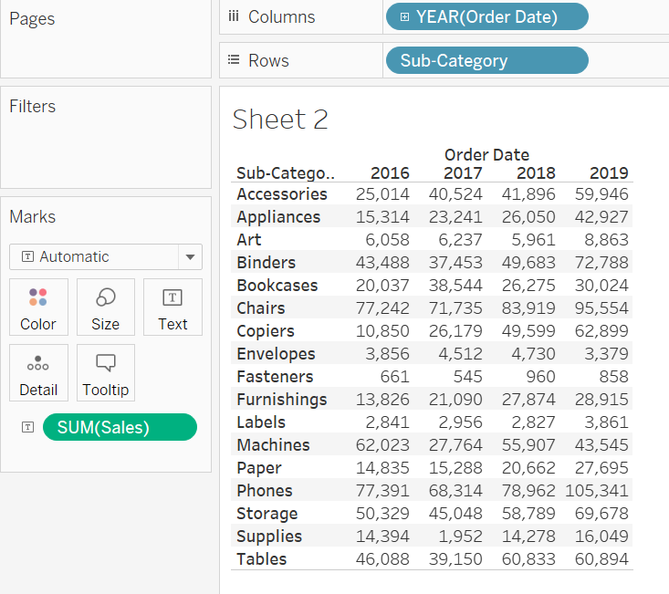

Apply the "Year over Year Growth" Quick table calculation in SUM(sales). So it will look like this:

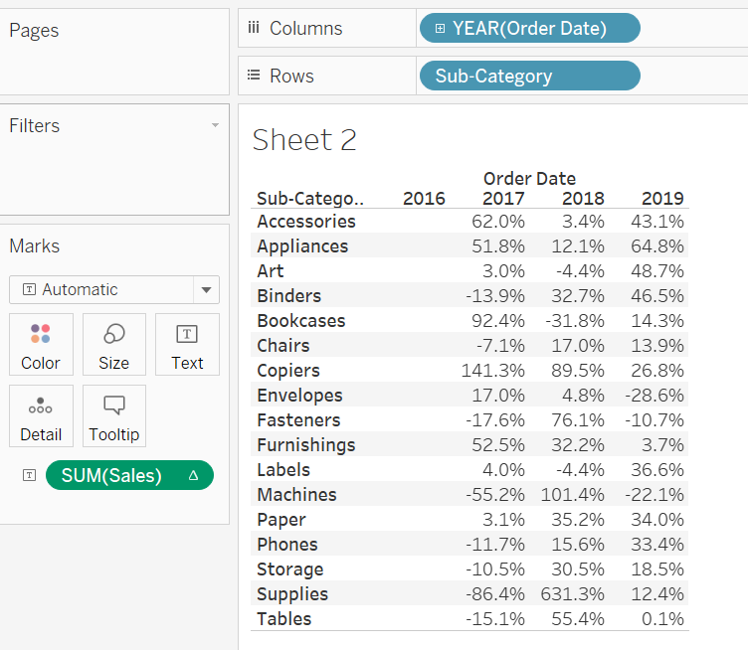

**33.4%** was the difference in sales of Phones subcategory in 2019 compared to 2018.

**Question 2:**

Create a view to find out what was the profit ratio for Technology Category in 2019?

1. **18.65%**
2. 17.23%
3. 18.9%
4. 17.5%

**Solution -**

Create a Calculated field "Profit Ratio" using the formula SUM([Profit])/SUM([Sales]).

Drop Category to Columns, Order Date to Rows, and Profit Ratio to Text. Right-click on profit ratio, click on format, change the Numbers format to percentage. So your final chart would look like this:

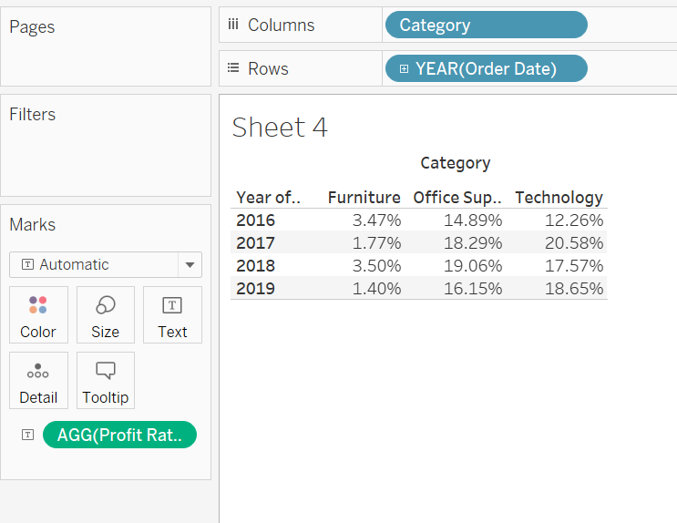

**18.65%** was the profit ratio for Technology Category in 2019.

**Question 3:**

Create a crosstab to find out the average sales of all categories in all regions?

1. 452.7
2. **309**
3. 226.5
4. 229.9

**Solution -**

Drop Category to Rows, and drop Region to Columns. Drop Sales to the Text and change the aggregation from SUM to AVG.

Then go to Analysis Menu -> Totals -> Show Row Grand Totals.

Again go to Analysis Menu -> Totals -> Show Column Grand Totals.

Your view would look like this:

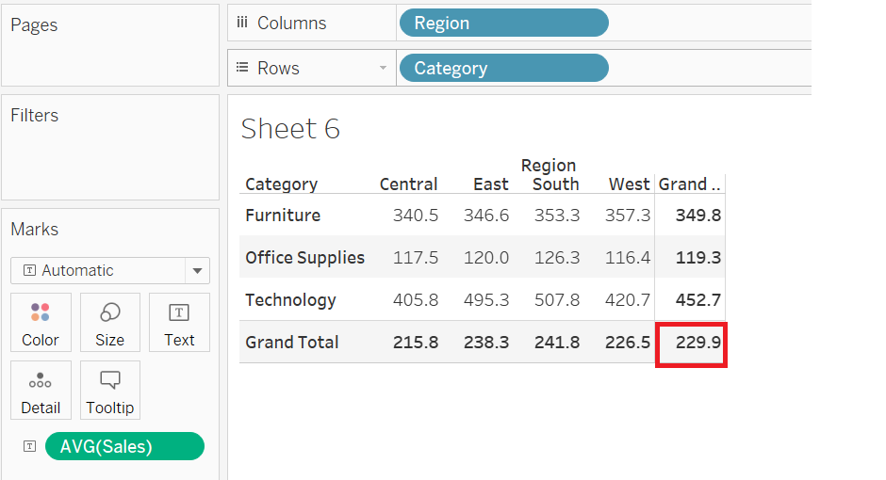

If you get 229.9 then it is not the correct answer, as you have to do one more step to find the average correctly. Select the 'Average' in Total All using as shown below:

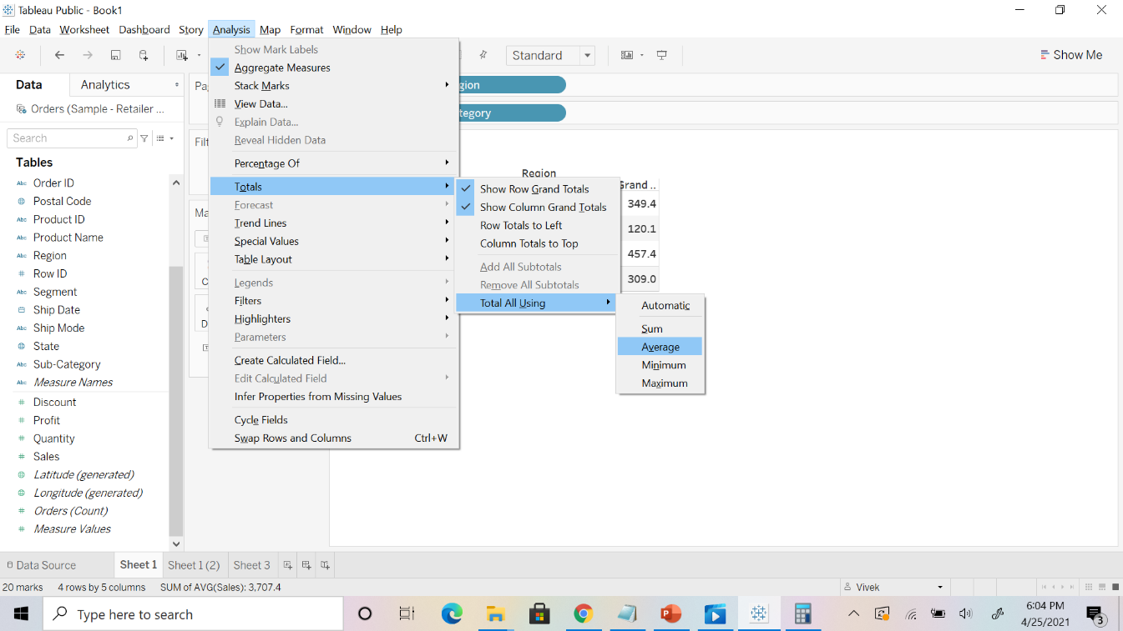

Your final view would look like this:

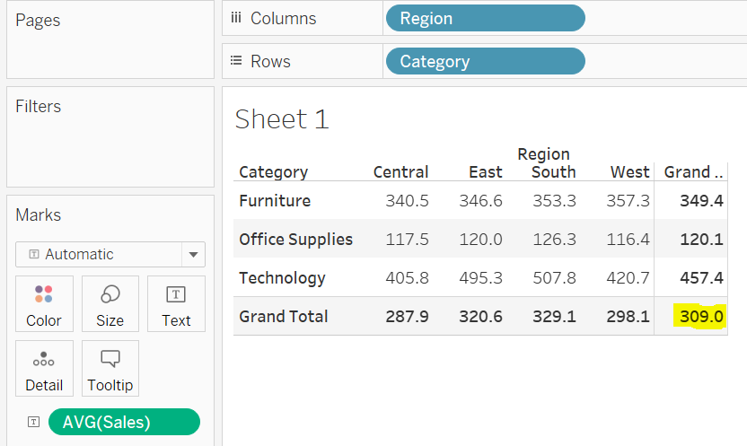

As here we have to find the average of the entire table so **309** was the average sales of all categories in all regions.

Question 4:

For any aggregate calculation, can we combine an aggregated value and a disaggregated value?

1. True
2. **False**

Question 5:

Level Of Detail (LOD) filters are executed before context filters?

1. True
2. **False**